Mizer sets up the initial whiting spectrum, and underlying resource spectrum according to a power-law. Running the system without discarding for an amount of time corresponding to 40 years yields the basic results:

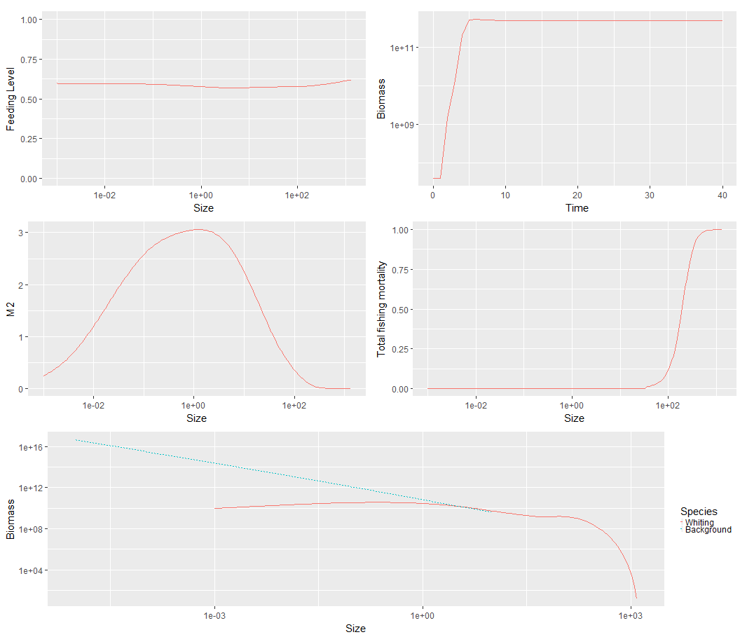
The system seems to be attracted to a fixed point where the biomass curve is mostly flat.

Now let us run the simulation again, with discarding, for now let us set the disintegration rate g_{d} =1.

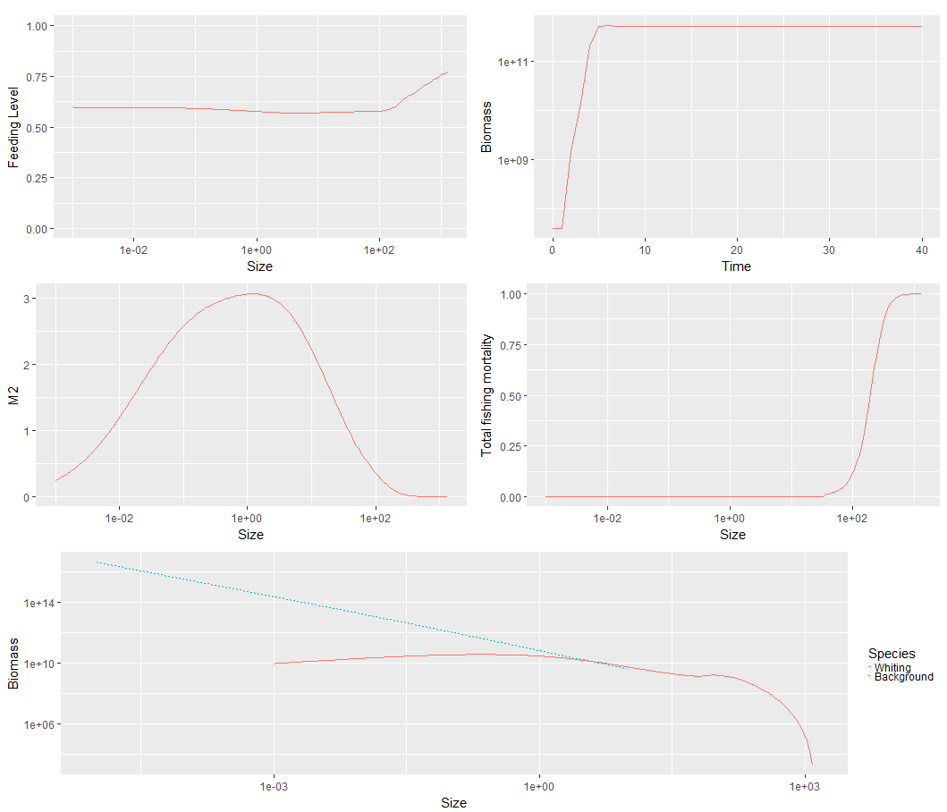
The results shown above (where fish caught under 250 g are discarded), look similar to those without discarding, however there are differences. The feeding level and biomass tend to be higher for larger fish when discarding is included.

Comparing the final abundance of whiting in these two situations, we can see confirmation of this (here the red line is for the case where discarding is included):

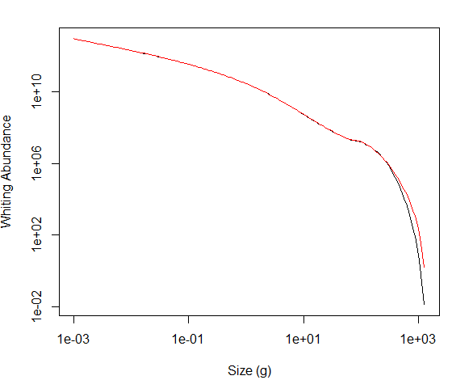
Let us look at more plots to increase our understanding of the dynamics of discarding. Below we show a plot on the influx I(w) of dead fish due to discarding. This appears to reach a steady state with time.
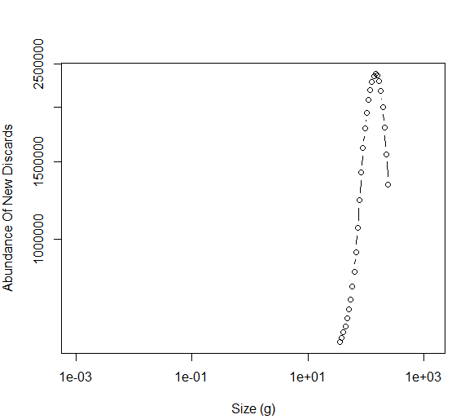

The drop to zero on the left happens because few fish below a given size are caught. The drop off on the right happens because no fish above 250 g are discarded. The final abundance of dead fish is plotted below:
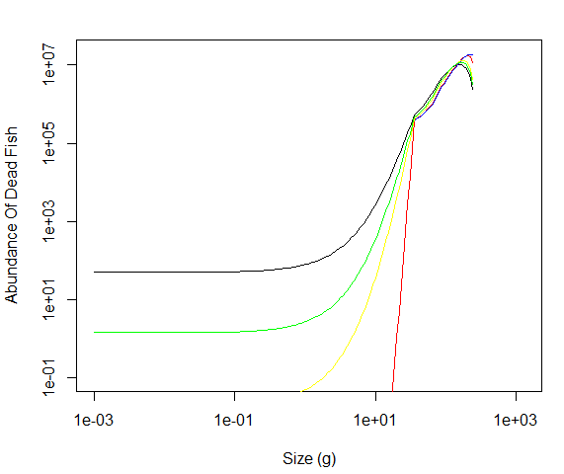
Here the blue, red, yellow, green and black curves show the final abundance of dead fish when the disintegration rate is 0, 1, 5, 7 and 10, respectively. It appears that there is a critical disintegration rate somewhere between 5 and 7, beyond which the amount of small dead fish build up significantly. It is worth bearing in mind that the disintegration can move masses of dead fish below the minimum size of the prey of the tiniest fish (i.e., below the size of the smallest plankton that fish can eat), and such mass will no longer be able to influence our system. This above plot shows how the disintegration rate can have a significant effect upon the qualitative nature of our output, so it is worth checking how discarding effects abundance in the regime where the disintegration rate is high (equal to 10).
Below made another plot showing the difference that discarding makes to the final abundance of whiting in this regime where the disintegration rate is large (red is for the case with discarding):

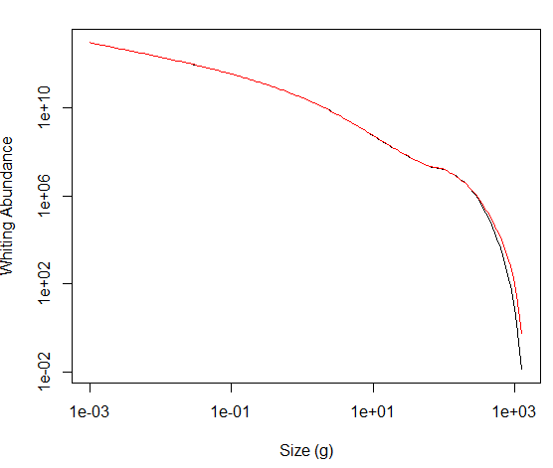
Another important issue is how the abundance of dead fish changes over time. Below we provide a plot for this, for the case where the disintegration rate is 1.
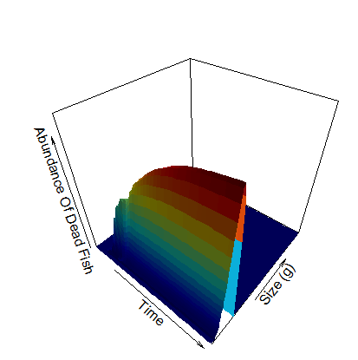

Here all axes have linear scale/ This shows good evidence that the abundance of dead fish is reaching a stationary distribution.
The 3D plot for the case where the disintegration rate is higher looks similar to the above, because the linear scale is inappropriate for showing the build up of small dead fish. In order to see this comparison in 3D. In order to do this we first plot the same date as above (with disintegration rate 1), but we take the logs of the size and abundance:

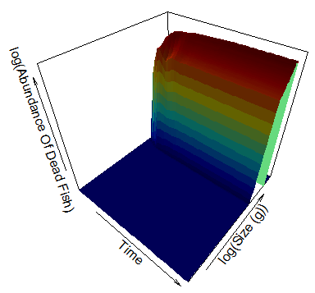

Below we make a similar plot when the disintegration rate is 10:
